Collision Course
Technology & Engineering
Forces and Motion

Objective: Using only the parts provided, design a vehicle that will travel down a specified course, collide with and derail, destroy, demolish, or obliterate another vehicle built with matching criteria traveling in the exact opposite direction on a collision course. The vehicle that remains on the track or demonstrates the least displacement will be the winner of the momentum challenge.

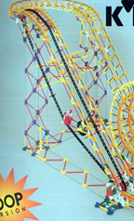
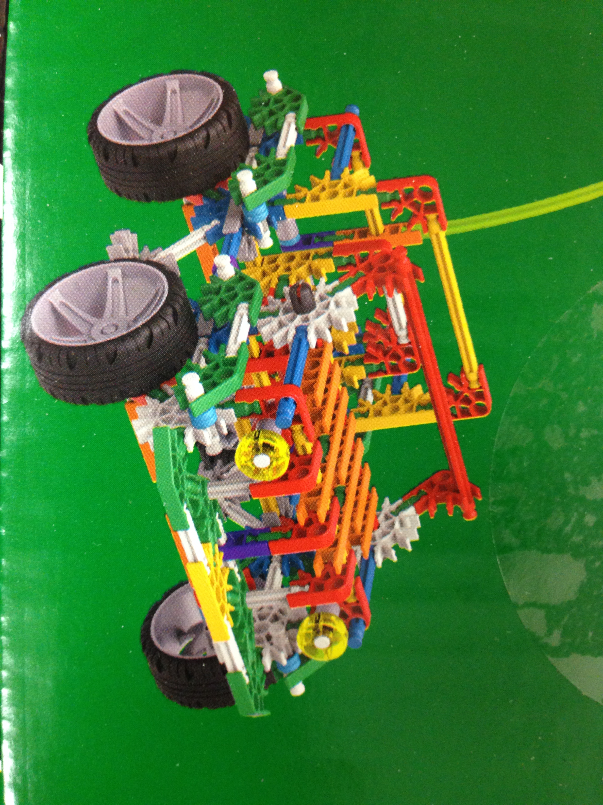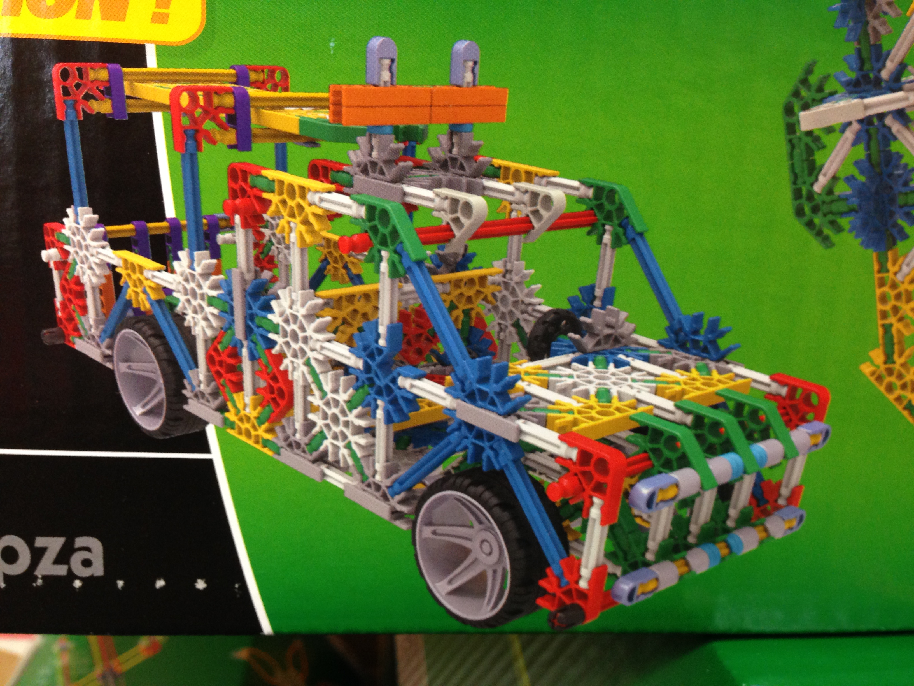
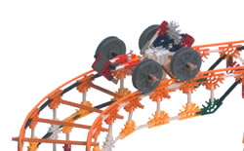

For this challenge, teams may use only the contents of one standard K’nex
kit. The kit will be provided by Mr. Roth and will be identical for all groups.

Some additional parts may be available from Mr. Roth on an as-needed basis.

General Rules that apply to this challenge. Your vehicle:
- Must be constructed using only the contents of one (1) standard K’nex kit.
- Must have at least two (4) wheels that allow it to ride on the course rails.
- Must be designed to ride along the rails of the course, travelling down the straight incline, and colliding with an opponent’s vehicle, which will be travelling down an identical rail system on the other side of the course.
- Must be designed to have the most momentum and inflict the most damage on an opponent’s vehicle as they collide at the bottom of the course.
- Must be designed to remain on the rails.
- A vehicle is “derailed” if it comes to rest and is not on it’s wheels and riding on the course rails.

The winner will be determined by:
- The vehicle that remains upright on the rails will automatically be the winner.
- In the event that BOTH vehicles remain upright on the rails, the vehicle that carries the most momentum, as evidenced by imparting a negative velocity on the other vehicle, will be the winner.
- In the event that BOTH vehicles become derailed, the winner will be determined by:
  - If one vehicle is completely derailed and the other remains on the rails, but fails to remain upright, the second will be considered the winner.
  - If both vehicles are completely derailed, the one with the most forward (positive) displacement will be the winner.
  - If both vehicles are completely derailed, and come to rest with approximately equal forward (positive) displacement, the one with the least damage will be the winner.

Collision Course
Rubric

